9.91: We can use 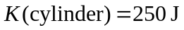 to find for the cylinder and for the mass.

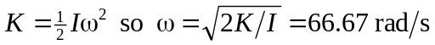
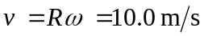
Use conservation of energy 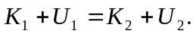 Take 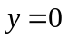 at lowest point of the mass, so 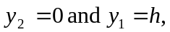 the distance the mass descends. 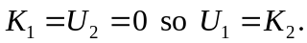
For the cylinder,
